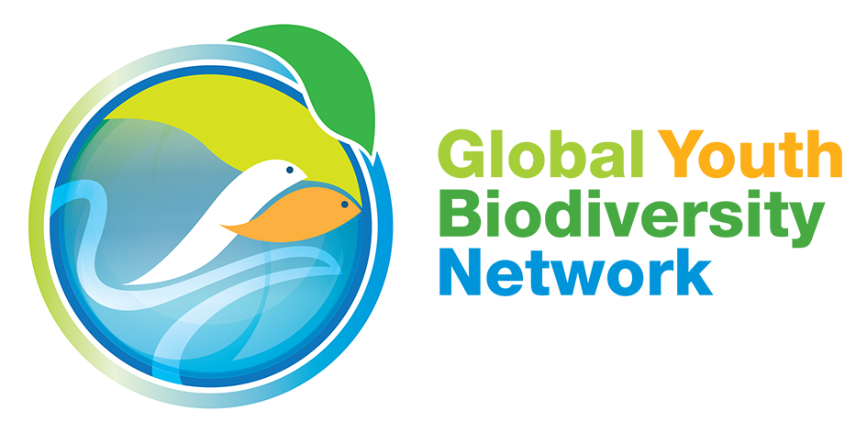

Second Meeting of the Open-ended Working Group on the Post-2020 Global Biodiversity Framework
Opening Statement
24 February 2020
Rome, Italy

[DELIVERED]

Thank you Co-Chair.

Dear Delegates

Before we begin, we would like to take a moment of silence for Ghanimat Azhdari, a young indigenous woman scientist and environmental human rights activist from the Qashqai peoples of Iran who was among the victims of the Ukranian Airlines flight that was mistakenly shot down over Iran last month.

(30 seconds Silence)

Thank you for taking this moment with us. A true force of nature, Ghanimat was a fierce, brave and bold young woman, inspiring, generous, warm and with a huge heart. These are the characteristics that we all need right now to make this a truly transformative path for change. Let's take inspiration from her and courageously embark on this journey.

Dear delegates, we want to ask you: Where do we go from zero?

We are here to discuss the zero draft - the first glimpse into what a global agreement on our shared future could look like. By the end of the week, we want to go from a zero draft to concrete recommendations for a Post-2020 Framework that shows the path to transformation - one that is not only a successful agreement, but that delivers on the vision to live in harmony within nature.

There is a strong focus on numbers in the current zero draft. And we believe that important issues might have been overshadowed by some of the current numbers in the framework. Here are some numbers that should matter even more:

3 - We need to clearly reflect the 3 objectives of the convention at the goal level in a balanced way, meaning conserving the integrity of our life support system, sustainable use for the whole of society, and equity not just in the context of access and benefit sharing of genetic resources, but in a broader sense of ensuring that no one is left behind.

4 - IPBES lists 4 underlying drivers of biodiversity loss underpinned by 2 things: values and behaviors. These are not sufficiently addressed in the zero draft. If we continue to focus just on the symptoms of our planetary crisis, we will find ourselves in the same place in 2030, in 2050. To do this we need to have a standalone target on transformative education that puts us on a path to reconnect with nature and restore our sense of responsibility to mother earth.

8 - The zero draft lists 8 enabling conditions--all extremely crucial to the success of any targets we develop. But how do we ensure these are being implemented when there is no mechanism to monitor them?

27 - There are 27 principles in the Rio Declaration that guide a pathway to sustainability. The framework needs a clearer recognition of principles, such as the precautionary principle, polluter pays principles, common but differentiated responsibilities and intergenerational equity, to guide our actions.

120 billion USD. It was assessed that we need 120 billion USD to implement the Strategic Plan. Yet, we spend 261 billion on agricultural subsidies annually and 1,753 billion on military expenditure. We need to increase finances for biodiversity and reform subsidies.

50% of the world’s population are aged under 30: youth and children. We need to make sure they are at the table in decisions about their present and future, and actively establish mechanisms to ensure this. We point out the glaring absence of youth and children indicators in the monitoring framework.

A quarter - A quarter of the global land area is traditionally owned, managed, used or occupied by indigenous peoples and local communities. These areas are “islands of nature and culture in a sea of decline”. If we are genuine in our intent to develop a truly transformative framework, we should not settle for one that ignores this. We need a target that appropriately recognizes IPLCs rights to their collective lands, territories, and resources and their self-determined systems of governance, knowledge and practices.

In 2019 alone, 121 environmental defenders were reported killed--and many more harrassed, criminalized, and threatened because they protect biodiversity and their territories. Women and girls in particular face gender-based violence. These are driven by those who continue unsustainable development models: mega projects, dams, mining, infrastructure which are also biodiversity loss drivers. It is our responsibility to ensure that biodiversity’s guardians are able to work in a safe and enabling environment, free from threat, restriction, and insecurity.

Half - Women and girls make up half of the world. Half the world that has been made vulnerable by oppressive systems and face increased risk to biodiversity loss; and whose crucial contributions to biodiversity are being made invisible. Gender considerations need to be present all throughout the framework as target components and in the monitoring and financial mechanisms.

There are many numbers that could be useful to develop a global biodiversity framework for all, but we must never forget what is incalculable:

Biodiversity cannot be measured, represented nor valued just by one dimension, or the numbers of people that get water or food, or the size of protected areas. It is the very system that supports our life and our well-being, and nurtures our culture and beliefs. We should boldly take on the challenge of taking into account all its layers and complexities.

Finally, One - We have one planet. Countless futures. Eight months. Let’s make it count.

Thank you Chair.

