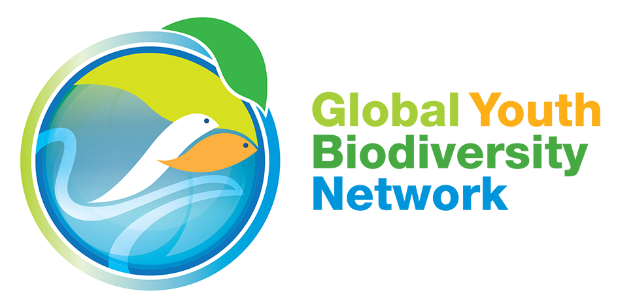

Second Meeting of the Open-ended Working Group on the Post-2020 Global Biodiversity Framework
Closing Statement
29 February 2020
Rome, Italy

Thank you Co-chairs. I am speaking on behalf of the Global Youth Biodiversity Network.

Dear Delegates,

It has been an intense week here in Rome with long nights, but we believe all the hard work is showing and taking us beyond Zero, building it up and moving forward. We appreciate the commitment we all have shown in integrating text that supports a strong, just, inclusive and rights-based framework. A framework that speaks to all and galvanizes support and action from all, to ensure our shared future within nature for all generations to come.

We understand that we are here to negotiate over words, to come up with the best language possible that will enable governments, rights-holders, civil society, organizations and institutions to make the transformation we need concrete and real.

There is more to be done: we need to strengthen the crucial sections of the framework. It has been said before: implementation, implementation, implementation. This is what will ultimately make us or break us. We need a robust monitoring framework underpinned by indicators that ensure the implementation of these words, as well as adequate financial resources, capacity building, and public mobilization in order to increase political will.

We have 8 months ahead of us now - 8 months to bring a breath of life to these words and make them alive.

They need to grow and blossom to truly represent the voices of the people, the songs of the birds, the roaring of the oceans and the *whispers of the forest*. As we spend hours in these conference halls, let’s keep our ears open and listen closely to what they tell us.

[slowly:] In the coming months, let’s fill this framework with meaning, with ACTION. Let's fill these words with LIFE.

Thank you very much.

