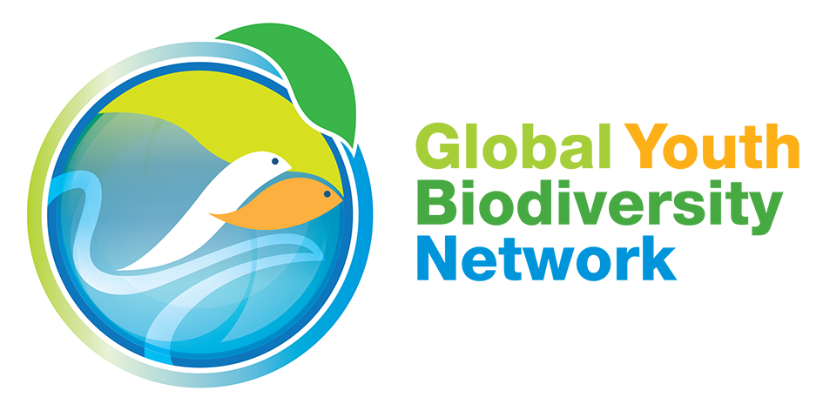

Second Meeting of the Open-ended Working Group on the Post-2020 Global Biodiversity Framework
Item 4 - Post 2020 Global Biodiversity Framework
24 February 2020
Rome, Italy

Thank you Co-chair. I am speaking on behalf of the Global Youth Biodiversity Network. We are bringing the voices of young people from at least 121 countries throughout 3 years of consultations.

With regard to the zero draft:

- We think that the current goals as listed in the zero draft of the post-2020 Global Biodiversity Framework could be clearer, addressing the 3 objectives of the convention in a more comprehensive way.

- For this reason, we suggest the following outcome-based goals instead: 1. Conserving the integrity of our life support system; 2. Society living sustainably, and 3. Equity for nature and people. These goals then have corresponding targets under each of them.

- As a suggestion to ease communication and understanding for all actors, we think it is useful to introduce sub-targets into the framework. This avoids overloading any one target with too many elements. To make it more intuitive, we feel it is important that the targets correlate to the goals, and that the goals clearly add up to the bigger picture.

Our proposals on the targets would be the following:

- Transformative education: While we welcome the reference to transformational change in the preambular sections, we point out again that the zero draft could better address the indirect drivers and root causes of biodiversity loss. An important way in which we can do this is by including and implementing a stand-alone target on transformative education that enhances biodiversity and sustainability literacy, reconnecting people within nature.

- Human rights: A rights-based approach is mentioned in the Theory of change. To operationalize this, we need to reflect the mutual dependence of human rights and the conservation and sustainable use of biodiversity--by strongly reflecting and ensuring the respect for the rights of children and youth, the rights of indigenous peoples and local communities, and the rights of women and girls in the targets.

- There are a few other elements that we think are missing and we hope they can be tackled in the contact groups. These are: elements on culture and intergenerational transmission of knowledge and language; elements that aim to recognize the rights of indigenous peoples and local communities to their collective lands, waters, resources and territories; a target that aims to ensure the safety of the defenders of the environment; and a reference to the intrinsic value and rights of nature.

Finally, we re-emphasize the importance of having clear provisions within goals and targets for means of implementation, and the monitoring of enabling conditions.

A youth perspective on the post-2020 GBF with these recommendations can be read here.

Thank you Chair.

